Installing and Using the Descriptions macro in GSAK

First download the Descriptions.gsk file from the web site and save it into the Macros folder for GSAK (C:\Program Files\GSAK\Macros).
To now use the macro when creating your Memory-Map export you need to do the following:

Go to “File” at the top of GSAK and select “Export” then “Memory Map…”
The screen show below will appear. At this point you need to add the following line in the “Waypoint Comment” field:-

%macro=”Descriptions.gsk”

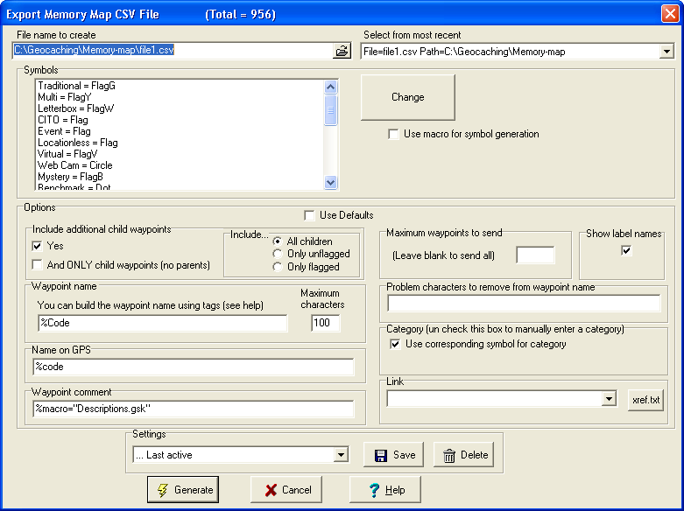

You should now be able to run the export so that it includes the Description of the cache under the properties for the waypoint on the Memory-Map screen.
All this information is carried across to your PDA when you export data from Memory-Map on your PC to your PDA.

Happy caching.

